CSIS 3175-001

INTRODUCTION TO MOBILE DEVELOPMENT



APPetizer CRAG Delivery Project Report

BY:

AGRIM UPPAL(300288770)

CHINOY SETHI(300283805)

GESSICA MATOS(300284935)

RITIKA SHARMA(300288772)

TO:

MEHWISH BASHIR

**INTRODUCTION**

**Are you hungry?????**

We are there for you 24/7 to finish your cravings. We are a Canadian mobile-food delivery marketplace headquartered in Vancouver. The service allows users to order food from restaurants which are near to their location and place orders via mobile.

We are a partnered with almost 1200 restaurants all over in Canada. Our delivery charges and very less compared to other food delivery apps out there.

Our mission is to bring good food to you everyday. We don’t just deliver food, we bring it, always going an extra mile to make your experience memorable. We want you to enjoy delicious food every day. Be it a healthy salad at work, or a extra large pizza for a game night with your buddies, we are always there for you.

Users can download this special android app in their android phones through google play. The next step is to register using your name, address and phone number and mainly the postal code which will help users connect to the nearest restaurants. After registration the user can start their journey of a great delivery experience with us.

Users can log into their accounts and choose a restaurant and place order and it will be delivered at their door-place in 50-60 minutes of timeframe depending on the distance between source and destination. Users will be able to add as many as items in their cart and place an order by using any payment method and receipt will be emailed to the user’s linked email account.

**PLATFORM**

* **FRONT END- Android Studio**

Android Studio is the official [integrated development environment](https://en.wikipedia.org/wiki/Integrated_development_environment) (IDE) for [Google](https://en.wikipedia.org/wiki/Google)'s [Android](https://en.wikipedia.org/wiki/Android_(operating_system)) [operating system](https://en.wikipedia.org/wiki/Operating_system), built on [JetBrains](https://en.wikipedia.org/wiki/JetBrains)' [IntelliJ IDEA](https://en.wikipedia.org/wiki/IntelliJ_IDEA) software and designed specifically for [Android development](https://en.wikipedia.org/wiki/Android_software_development). It is available for download on [Windows](https://en.wikipedia.org/wiki/Windows), [macOS](https://en.wikipedia.org/wiki/MacOS) and [Linux](https://en.wikipedia.org/wiki/Linux) based operating systems.

* **BACK END- DB Browser for SQL LITE**

DB Browser for SQLite (DB4S) is a high quality, visual, open source tool to create, design, and edit database files compatible with SQLite.

DB4S is for users and developers who want to create, search, and edit databases. DB4S uses a familiar spreadsheet-like interface, and complicated SQL commands do not have to be learned

* **TESTING TOOL- ANDROID EMULATOR**

**SOFTWARE DEVELOPMENT LIFE CYCLE**

**GENERAL TASKS:**

* **PLANNING: -**

1. Reviewing existing food delivery applications.
2. Extracting important ideas for project generation.
3. Deciding the features of the project.

* **REQUIREMENT ANALYSIS: -**

1. Analysis of the functional requirements with reference to already existing food delivery applications.

* **SOFTWARE DESIGN: -**

1. Implementation of the ideas in the first two phases.
2. Designing the user interface and all pages using android studio.
3. Creating the database and required tables and generating relationships amongst them.

* **SOFTWARE DEVELOPMENT: -**

1. Writing the code for all the pages of the application.
2. Writing the database code and linking it to android studio.

* **SOFTWARE TESTING: -**

1. Checking the working of the application when complied using all features with various test cases.
2. Testing on android phone/tablet.

* **SOFTWARE DEPLOYMENT: -**

1. Final project submission and presentation.

**FUNCTIONALITY**

* **Clean UI design**

The whole layout of the app has been kept very clean with clutter-free UI elements for a

pleasant user experience. This makes the app easy to access and navigate.

* **Quick Signup Process**

It takes only a few seconds for a new user to signup and start ordering food right away.

The database registers the address with the zip code and displays a list of restaurants

accordingly.

* **Customized ordering**

Users have full control over how they order. They can select various quantities and even

give special instructions to the restaurant if they want something specific.

* **Account Management**

There is an account management page where a user can edit and make changes to their

account information. Whether it is updating the address or adding a payment method, it

can all be done from the edit account page.

* **Payment Options**

Users have the option of selecting the delivery option, in which case they are charged

with a delivery fee. The app provides the most major payment methods for the

convenience of the user. After choosing from these options, the user can securely

checkout.

* **Order History Page**

All the User’s order history is conveniently stored in a section which the user can access

to keep a track of their purchases. This history gives them the necessary information like

their order date and time and type of payment, etc.

* **Expandability**

The app is designed to easily accommodate new users and restaurants in the system.

**SCREENSHOTS**

1. **Welcome Screen-** Welcome screen for signup and login options.

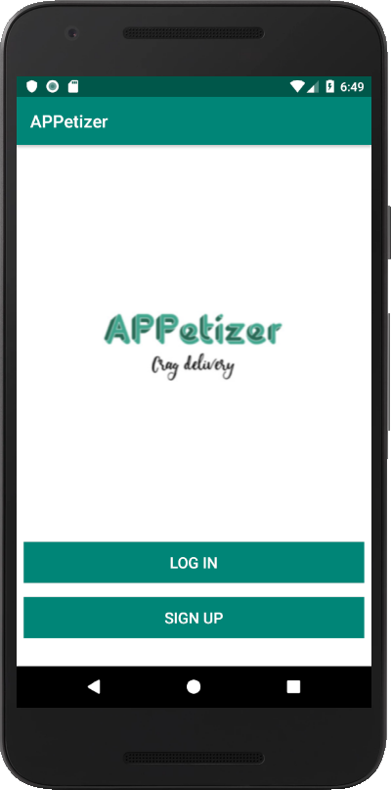

1. **Login Screen:** Existing users can login through this page.

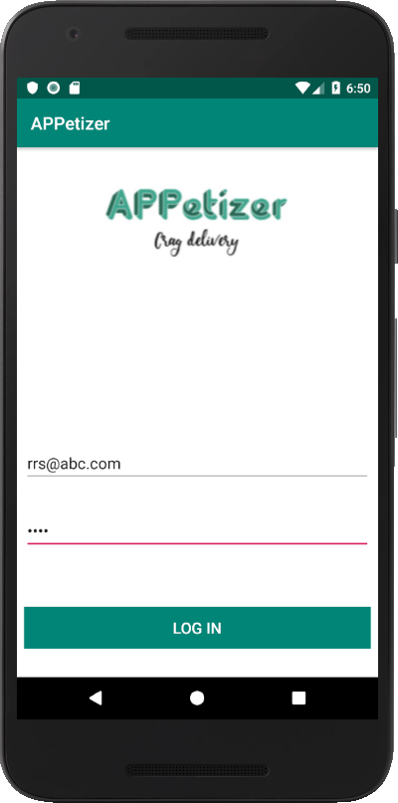

1. **Sign Up Screen-** New user can register to the app**.**

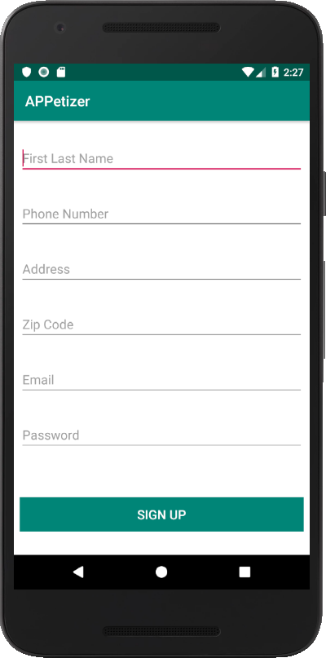

1. **Restaurant list for user-** List of restaurants that appear for user corresponding to zip code.

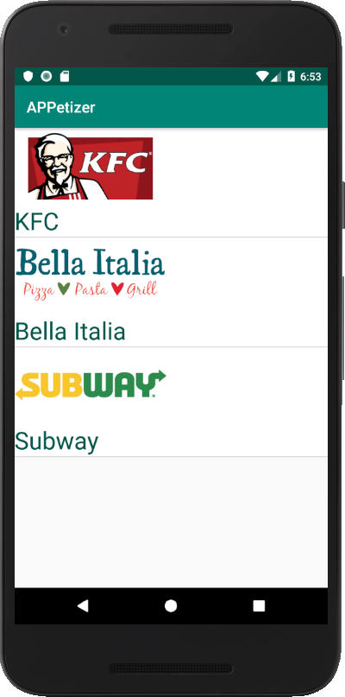

1. **Ordering from restaurant-** The menu list that appears corresponding to every restaurant.

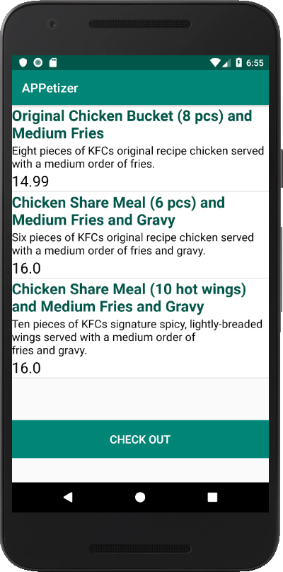

**6.Selecting Item-** Selection of item from the menu list with the quantity of the desired item.

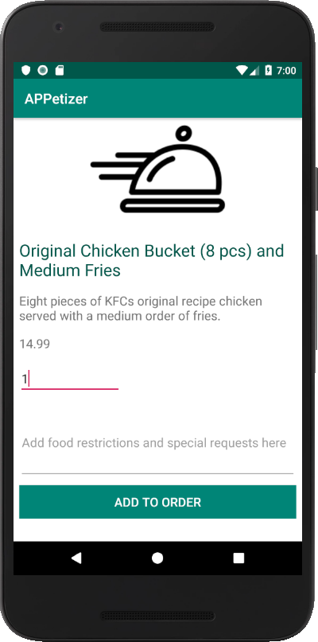

1. **Check out page**- Page after adding orders and proceeding for checkout.

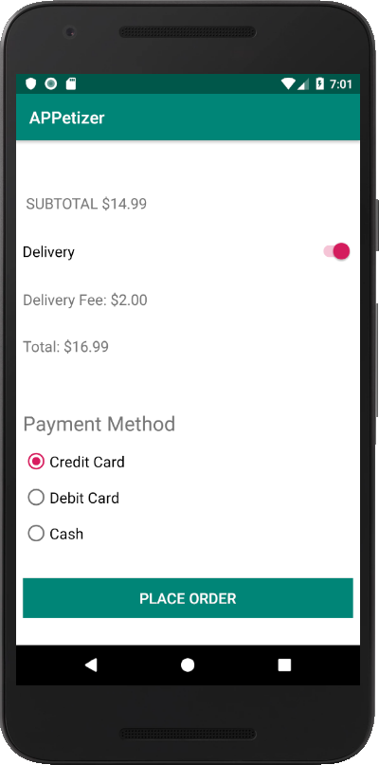

1. **Order History-** Order history of all the purchases of a user.

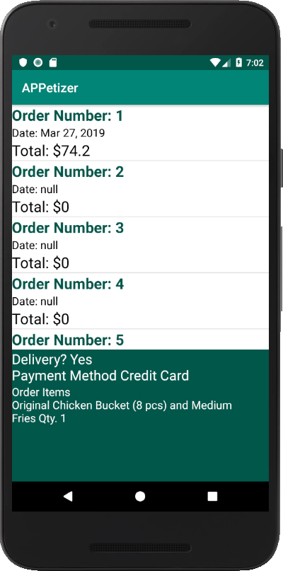

1. **User Account Information-** User account details available for updation by user.

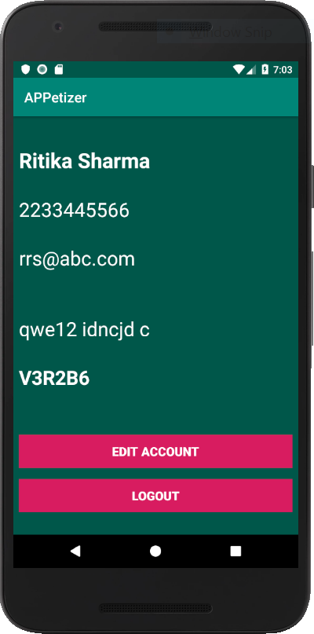

1. **Friend referral-** Referral to friends for discount of 10% on one order each time.

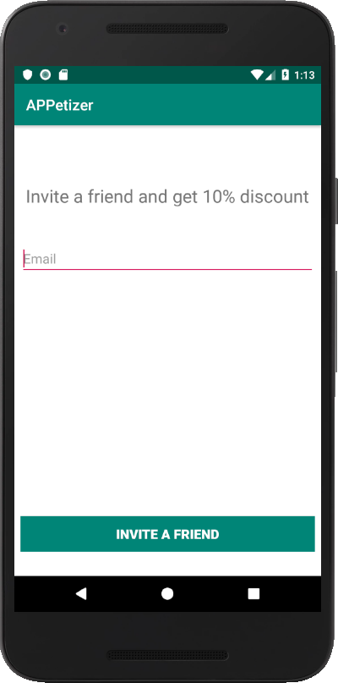

**JAVA CLASSES**

1. Account
2. Checkout
3. DatabaseHelper
4. Dish
5. History
6. Item
7. Login
8. MainActivity
9. Menu
10. MenuDish
11. Options
12. OrderDetail
13. Orders
14. Restaurants
15. RestaurauntList
16. SignUp
17. User
18. Invite

**DATABASE DESIGN AND TABLES**

1. List of all the tables.

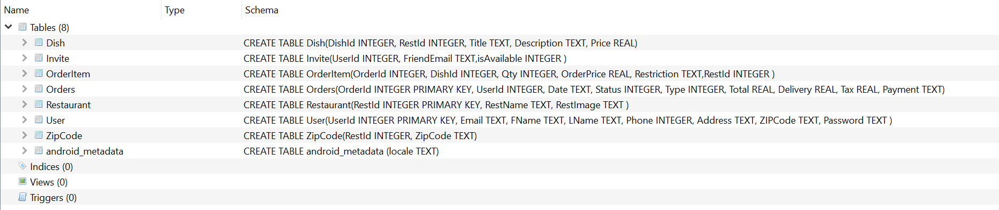

1. Dish Table

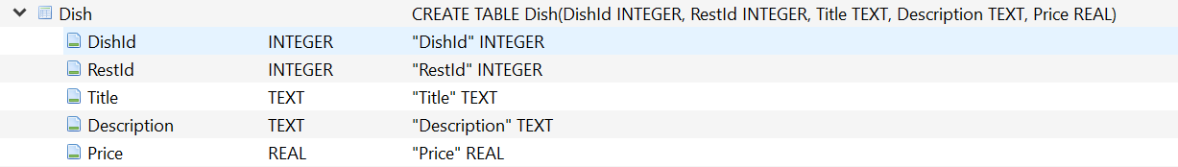

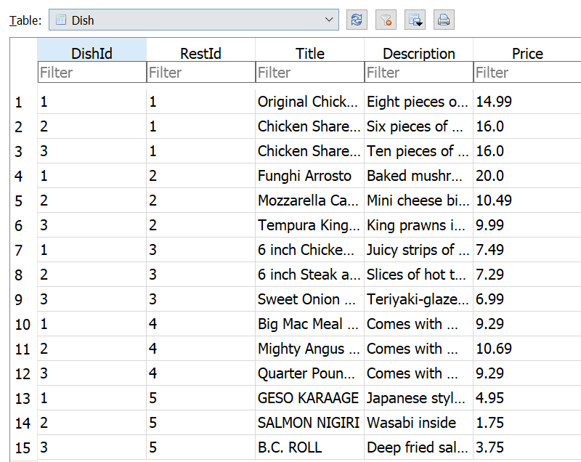

1. **Invite table-**

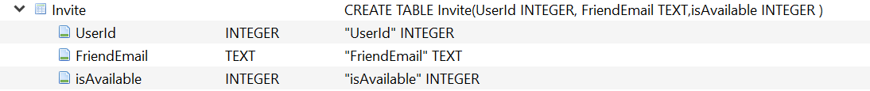

1. **Order item table-**

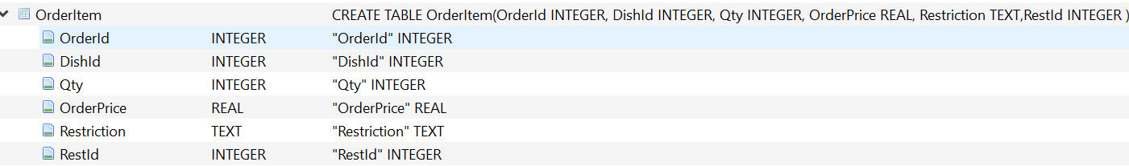

1. **Orders table-**

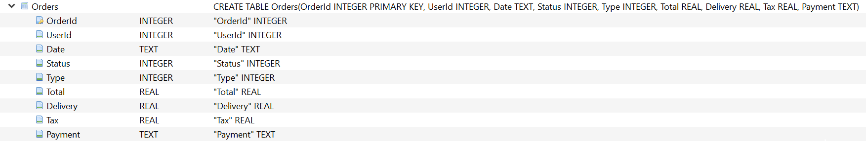

1. **Restaurants table-**



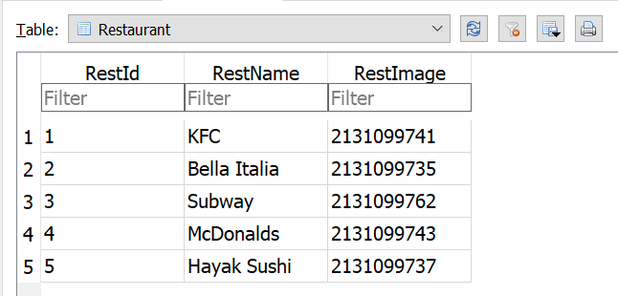

1. **User table**

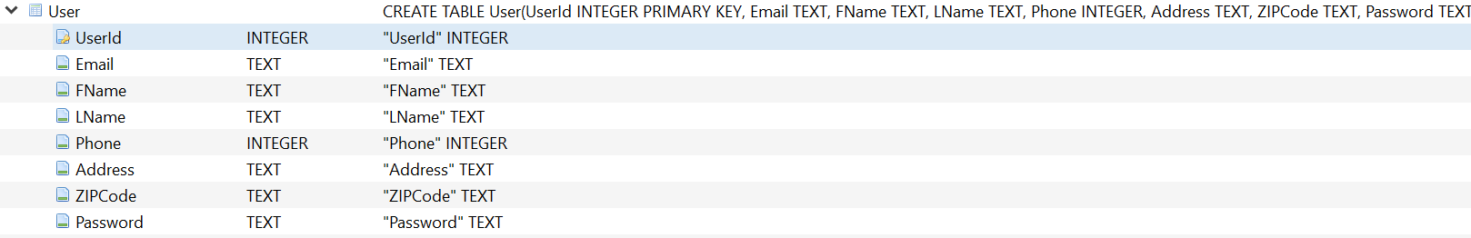

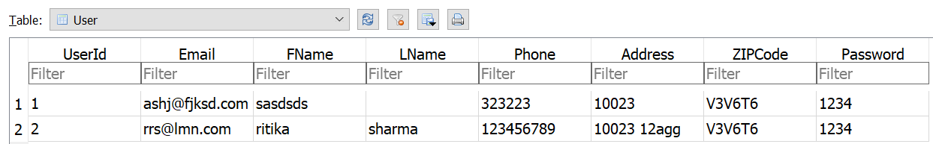

1. **Zip code table**



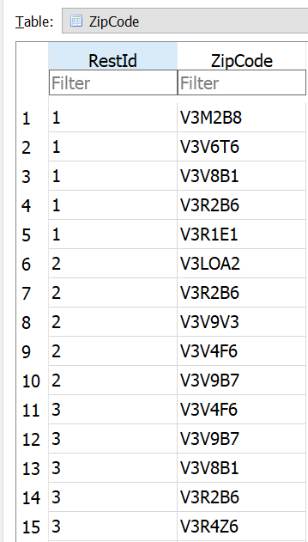

**TEAM CONTRIBUTION**

1. Gessica Matos- Coding, GUI, Database of User login, signup, account info and friend referral.
2. Ritika Sharma- Coding, GUI, Database of restaurants and menu pages.
3. Agrim Uppal- Coding, GUI, Database checkout, cart and design.
4. Chinoy Sethi- Coding, GUI, Database Order history, Testing of app at all stages and report generation.